**Digital Design and Computer Organisation Laboratory**

**UE22CS251A**

**3rd Semester, Academic Year 2023**

Date: 16-08-23

|  |  |  |
| --- | --- | --- |
| Name:  Gautam Vijay Hanchinal | SRN:  PES1UG22CS215 | Section  D |

Week#____1_______ Program Number: ____1___

TITLE:

**WRITE A VERILOG PROGRAM TO MODEL A TWO INPUT AND GATE. GENERATE THE VVP OUTPUT AND SIMULATION WAVEFORM USING GTKWAVE. VERIFY THE OUTPUT AND WAVEFORM WITH THE AND GATE TRUTH TABLE**

1. Verilog Code Screenshot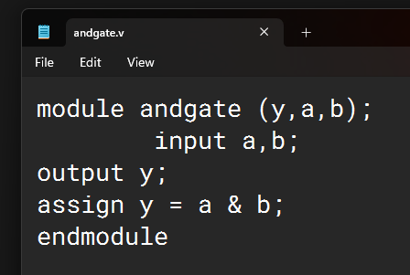

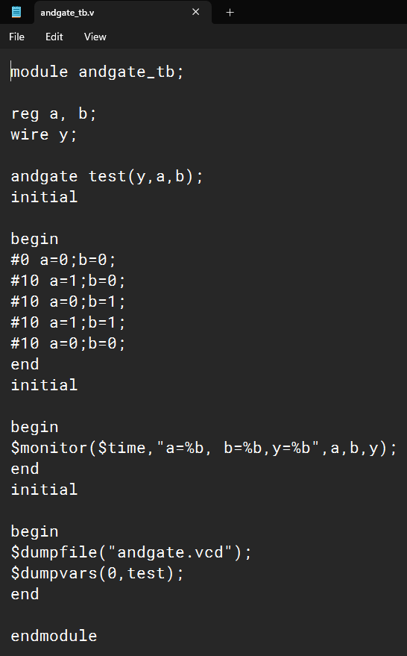

1. Verilog VVP Output Screen Shot

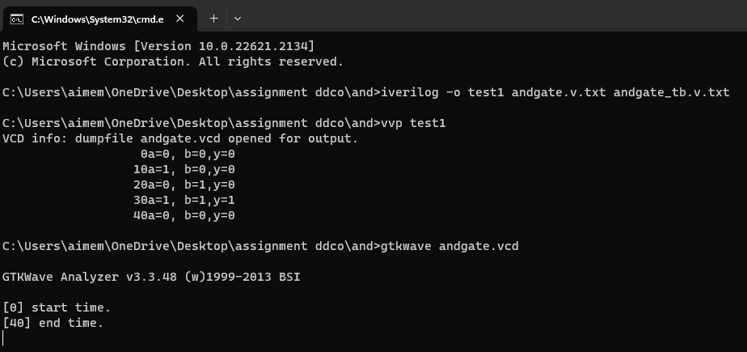

1. GTKWAVE Screenshot

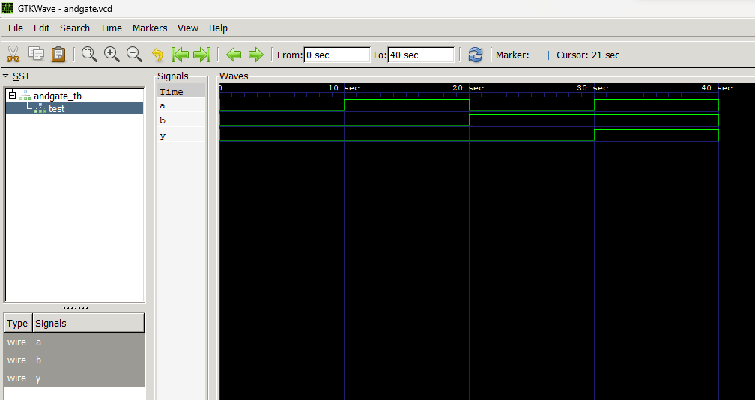

1. Output Table to be completed and included

|  |  |  |
| --- | --- | --- |
| **A** | **B** | **Y** |
| 0 | 0 | 0 |
| 0 | 1 | 0 |
| 1 | 0 | 0 |
| 1 | 1 | 1 |

Date: 16-08-23

|  |  |  |
| --- | --- | --- |
| Name:  Gautam Vijay Hanchinal | SRN:  PES1UG22CS215 | Section  D |

Week#____1_______ Program Number: ____2___

TITLE :

**WRITE A VERILOG PROGRAM TO MODEL A TWO INPUT OR GATE. GENERATE THE VVP OUTPUT AND SIMULATION WAVEFORM USING GTKWAVE. VERIFY THE OUTPUT AND WAVEFORM WITH THE OR GATE TRUTH TABLE**

1. Verilog Code Screenshot

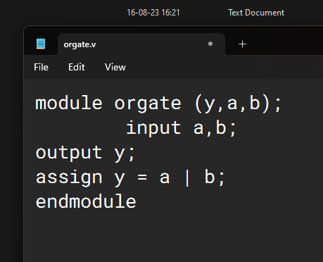

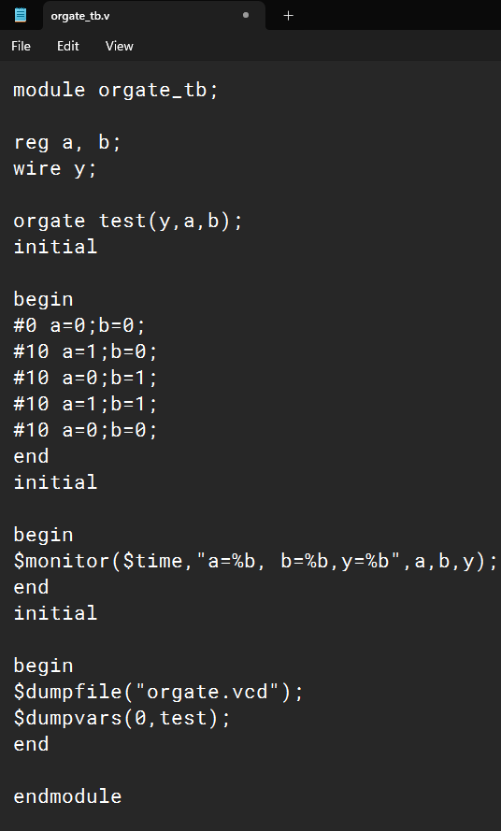

1. Verilog VVP Output Screen Shot

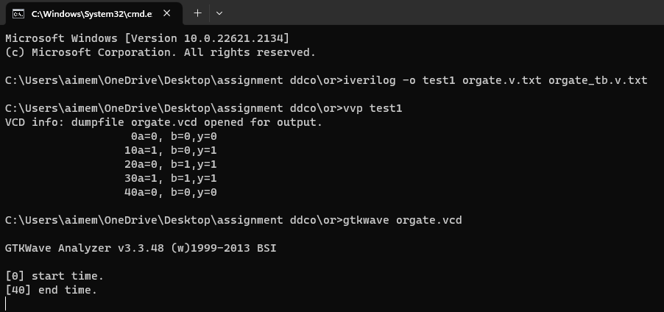

1. GTKWAVE Screenshot

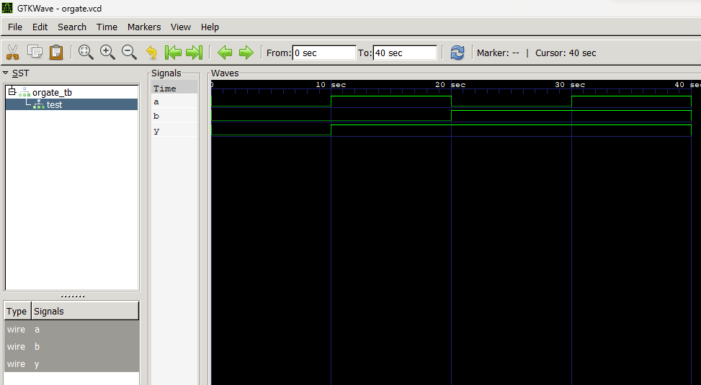

1. Output Table to be completed and included

|  |  |  |
| --- | --- | --- |
| **A** | **B** | **Y** |
| 0 | 0 | 0 |
| 0 | 1 | 1 |
| 1 | 0 | 1 |
| 1 | 1 | 1 |

Date: 16-08-23

|  |  |  |
| --- | --- | --- |
| Name:  Gautam Vijay Hanchinal | SRN:  PES1UG22CS215 | Section  D |

Week#____1_______ Program Number: ____3___

TITLE:

**WRITE A VERILOG PROGRAM TO MODEL A NOT GATE. GENERATE THE VVP OUTPUT AND SIMULATION WAVEFORM USING GTKWAVE. VERIFY THE OUTPUT AND WAVEFORM WITH THE NOT GATE TRUTH TABLE**

1. Verilog Code Screenshot

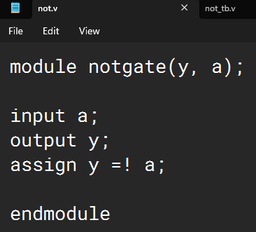

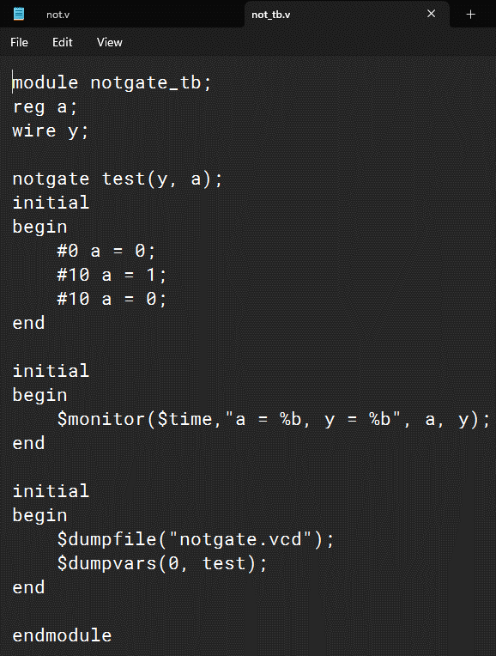

1. Verilog VVP Output Screen Shot

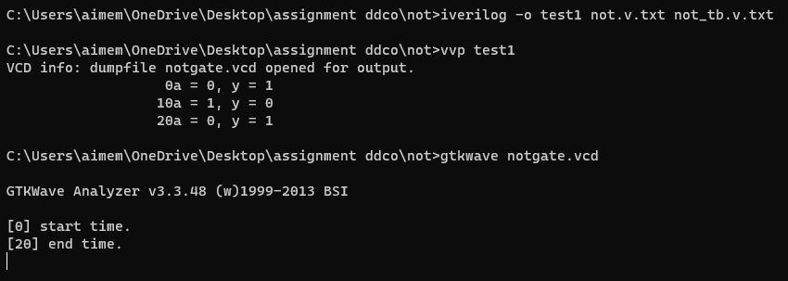

1. GTKWAVE Screenshot

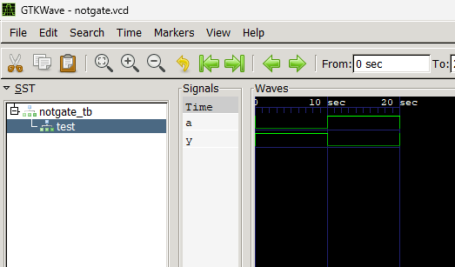

1. Output Table to be completed and included

|  |  |
| --- | --- |
| A | Y |
| 0 | 1 |
| 1 | 0 |

Date: 16-08-23

|  |  |  |
| --- | --- | --- |
| Name:  Gautam Vijay Hanchinal | SRN:  PES1UG22CS215 | Section  D |

Week#____1_______ Program Number: ____4___

TITLE :

**WRITE A VERILOG PROGRAM TO MODEL A TWO INPUT NAND GATE. GENERATE THE VVP OUTPUT AND SIMULATION WAVEFORM USING GTKWAVE. VERIFY THE OUTPUT AND WAVEFORM WITH THE NAND GATE TRUTH TABLE**

1. Verilog Code Screenshot

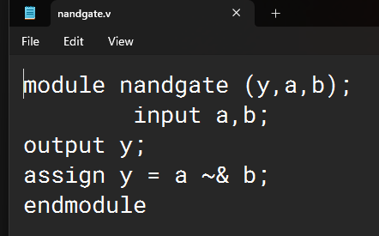

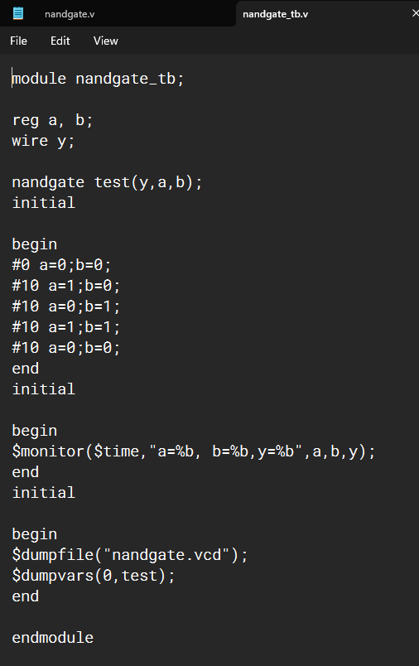

1. Verilog VVP Output Screen Shot

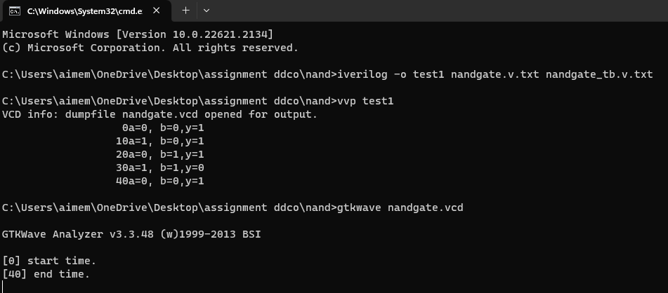

1. GTKWAVE Screenshot

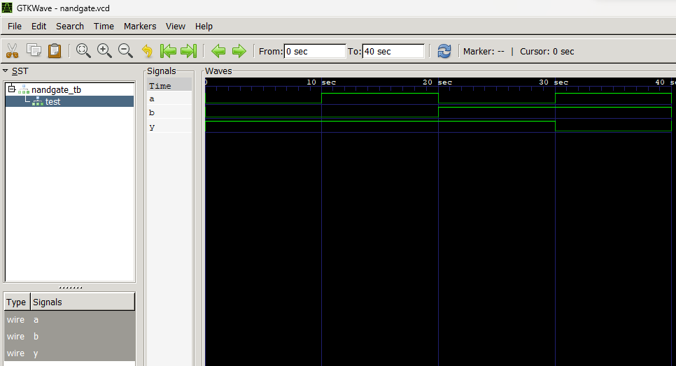

1. Output Table to be completed and included

|  |  |  |
| --- | --- | --- |
| **A** | **B** | **Y** |
| 0 | 0 | 1 |
| 0 | 1 | 1 |
| 1 | 0 | 1 |
| 1 | 1 | 0 |

Date: 16-08-23

|  |  |  |
| --- | --- | --- |
| Name:  Gautam Vijay Hanchinal | SRN:  PES1UG22CS215 | Section  D |

Week#____1_______ Program Number: ____5___

TITLE:

**WRITE A VERILOG PROGRAM TO MODEL A TWO INPUT NOR GATE. GENERATE THE VVP OUTPUT AND SIMULATION WAVEFORM USING GTKWAVE. VERIFY THE OUTPUT AND WAVEFORM WITH THE NOR GATE TRUTH TABLE**

1. Verilog Code Screenshot

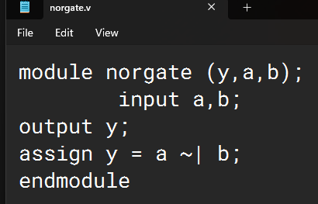

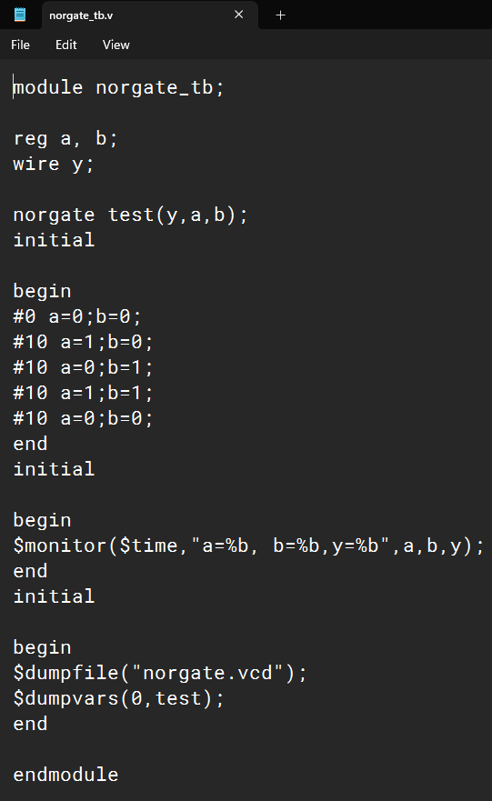

1. Verilog VVP Output Screen Shot

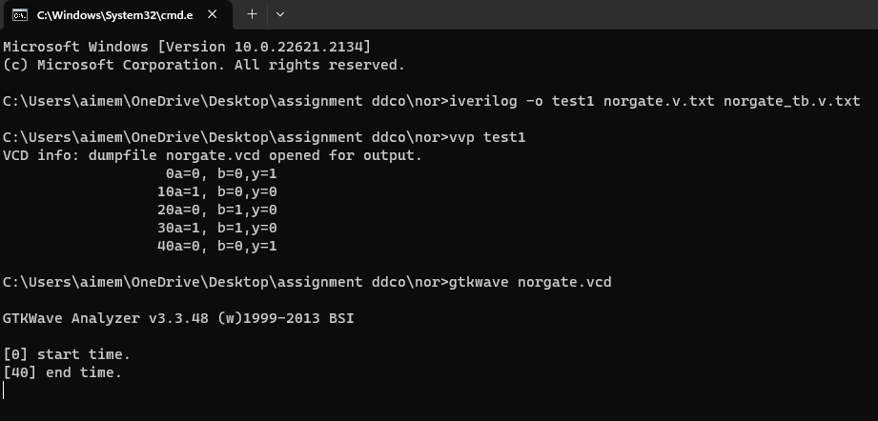

1. GTKWAVE Screenshot

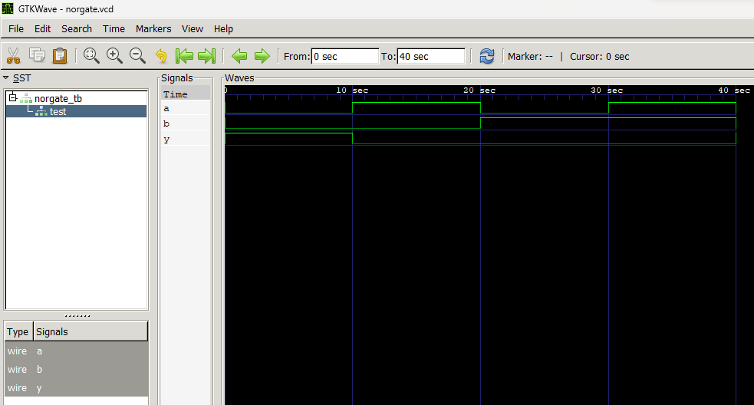

1. Output Table to be completed and included

|  |  |  |
| --- | --- | --- |
| **A** | **B** | **Y** |
| 0 | 0 | 1 |
| 0 | 1 | 0 |
| 1 | 0 | 0 |
| 1 | 1 | 0 |

Date: 16-08-23

|  |  |  |
| --- | --- | --- |
| Name:  Gautam Vijay Hanchinal | SRN:  PES1UG22CS215 | Section  D |

Week#____1_______ Program Number: ____6__

TITLE:

**WRITE A VERILOG PROGRAM TO MODEL A TWO INPUT XOR GATE. GENERATE THE VVP OUTPUT AND SIMULATION WAVEFORM USING GTKWAVE. VERIFY THE OUTPUT AND WAVEFORM WITH THE AND GATE TRUTH TABLE**

1. Verilog Code Screenshot

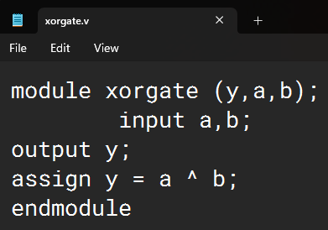

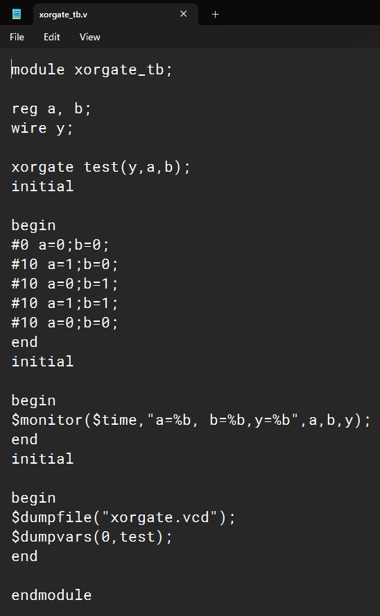

1. Verilog VVP Output Screen Shot

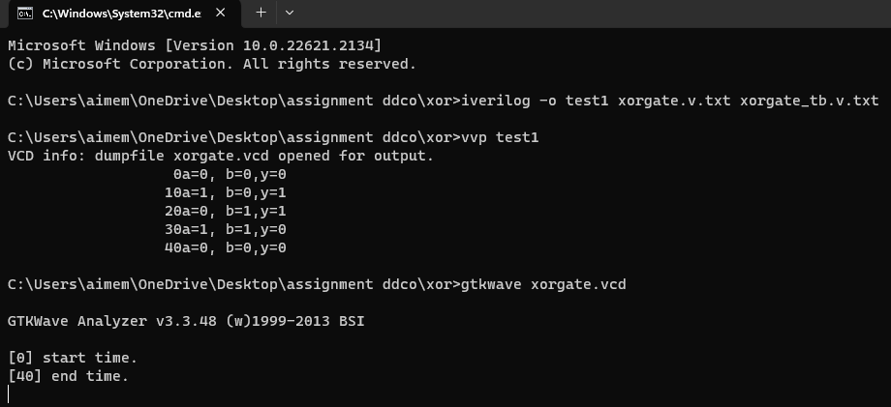

1. GTKWAVE Screenshot

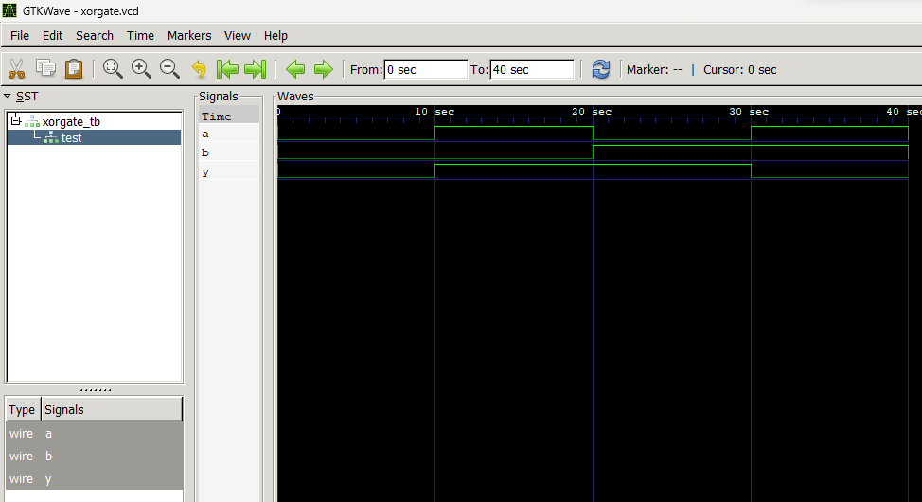

1. Output Table to be completed and included

|  |  |  |
| --- | --- | --- |
| **A** | **B** | **Y** |
| 0 | 0 | 0 |
| 0 | 1 | 1 |
| 1 | 0 | 1 |
| 1 | 1 | 0 |

Date: 16-08-23

|  |  |  |
| --- | --- | --- |
| Name:  Gautam Vijay Hanchinal | SRN:  PES1UG22CS215 | Section  D |

Week#____1_______ Program Number: ____7___

TITLE :

**WRITE A VERILOG PROGRAM TO MODEL A TWO INPUT XNOR GATE. GENERATE THE VVP OUTPUT AND SIMULATION WAVEFORM USING GTKWAVE. VERIFY THE OUTPUT AND WAVEFORM WITH THE AND GATE TRUTH TABLE**

1. Verilog Code Screenshot

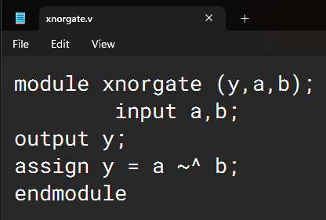

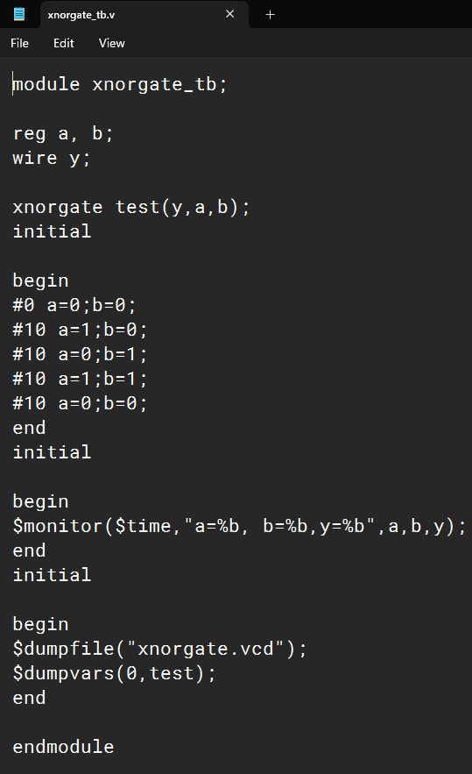

1. Verilog VVP Output Screen Shot

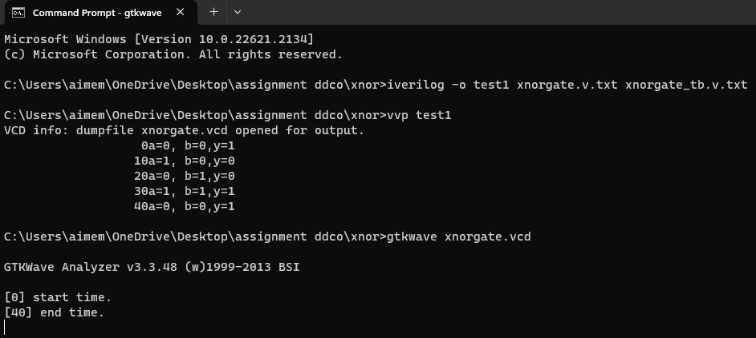

1. GTKWAVE Screenshot

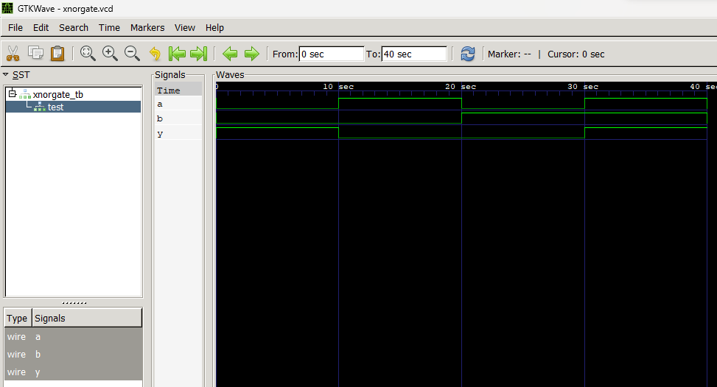

1. Output Table to be completed and included

|  |  |  |
| --- | --- | --- |
| **A** | **B** | **Y** |
| 0 | 0 | 1 |
| 0 | 1 | 0 |
| 1 | 0 | 0 |
| 1 | 1 | 1 |

**Disclaimer:**

* The programs and output submitted is duly written, verified and executed by me.
* I have not copied from any of my peers nor from the external resource such as internet.
* If found plagiarized, I will abide with the disciplinary action of the University.

Signature: Gautam Hanchinal

Name: Gautam Vijay Hanchinal

SRN: PES1UG22CS215

Section: D

Date: 16-08-23

